 | {{FIRM_NAME}}
 | WASHINGTON  253-215-1271  7602 BRIDGEPORT WAY W, SUITE 3B  LAKEWOOD, WASHINGTON 98499  FAX: (877) 813-6042
Client Name:
Date of Loss:
Current Lien Amount: % of final settlement
NOTICE OF CLAIM OF ATTORNEY’S LIEN PURSUANT TO RCW 60.40.010
NOTICE IS HEREBY GIVEN that {{FIRM_NAME}} claims a lien for its services upon the claims for relief on behalf of ___________________________against and any person, entity, or insurance company, legally liable for damages as a result of an incident occurring on ___________________, including, but not limited to: negligence, bad faith, breach of contract, breach of the covenant of good faith and fair dealing and malpractice (the “claim”).
{{FIRM_NAME}} claims a lien upon any and all property or amounts recovered (“the Recovery”) that may become available on behalf of ___________________.
Said claim against ___________________________recovery shall be % of all gross amounts recovered from any source, specifically including, but not limited to, any recovery from third parties, uninsured motorist, and/or underinsured motorist coverage and 40% after the filing of a formal lawsuit.
{{FIRM_NAME}}
By: | 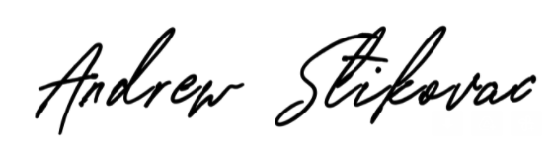
{{ATTORNEY_NAME}}, Esq.
Washington State Bar Association No. 58020
Signature | Date

WWW.GOLDMEDALINJURYLAW.COM | DON’T SETTLE. GO FOR THE GOLD.

